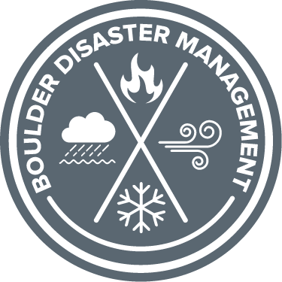
Boulder Office of Disaster Management
Creating a Plan Worksheet
Activity 1: Communication Planning
For your first step in communication planning, register for emergency alerts by visiting www.bocoalert.org, or downloading the ReachWell App and search for BOCO Alert.
- How do you plan to get notified about an emergency or disaster situations? Review different types of alerts at https://boulderodm.gov/preparedness/emergency-alerts/

- How will you communicate with others? What communication tools do you need (examples include a phone and charger, extra batteries for hearing aids, paper and a pen to write information down). Think about what you’ll need to communicate successfully.

- What are important phone numbers that you need? Write down names and important contact numbers.

- Who could you and family or friends use as your out-of-town contact to get in touch with? What is a location that you could use as a meet up location?

Activity 2: Evacuation Planning
- What are two or more routes that you could take out of your neighborhood or other frequented areas (like work, school, etc.) in the event of road closures?

- What are two modes of transportation you could use if you had to evacuate?

- Are there loved ones that you need to create a meet-up spot for? Where will that spot be?

- What supplies, if any, do you want to have on-hand in your vehicle/mode of transportation that may be useful during an evacuation?

- If you have a garage, do you know how to use the pull tab/have the physical ability to lift the door to get out if you lose power? If not, what would you plan to do if your vehicle was stuck inside?

Activity 3: Sheltering-in-Place Planning
- How will you maintain your access to food, water, shelter, health needs, power, and communications while staying in place?

Activity 4: Grab List Planning
- What are some items that you’d want to take with you in the event of an evacuation?

- What are some important items that you would want to be prepared with that would help you maintain your health and safety?

- Write down your most important grab list items below. Include the item, and its location in your home.
Item | Location

